|  |
| --- |
| WHAT PASSPORT WILL REIMBURSE |

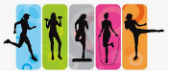 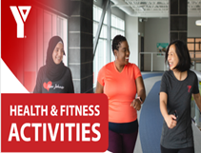 

Gyms and YMCA memberships Participate in sports leagues

 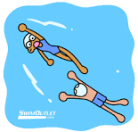 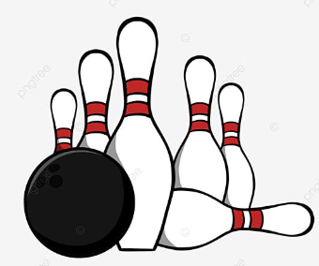 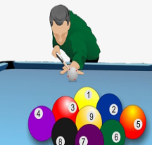  

Sporting events and concerts Activitieslike swimming, bowling, pool, golf Permits or licenses

 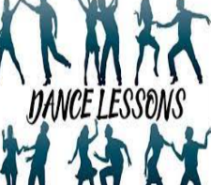 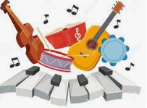 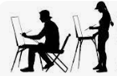  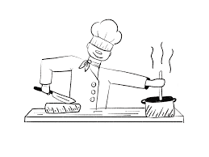

Lessons like horse back riding, dance, music, painting, photography, cooking = learning a new skill or hobby

 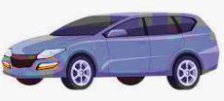  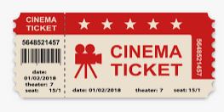

Transportationlike a taxi, bus, GoTrain Activity based day/summer camp Tickets for plays or movies

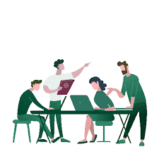   

Community classes and workshops Club memberships like fishing, Legion Out of home respite, support worker

 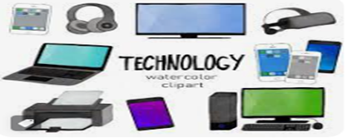 

Technology **UP TO $3,000.00** Supplies and Equipment **UP TO $2,000.00**

EXAMPLES: laptop, headphone, EXAMPLES: crafts, books, movies,

iPad or tablet, tv, cell phone, games, sensory items, fitness equipment

smart watch

   

Amusement parks, museums, cultural attractions tickets/admission fees

**LIVE EVENT TICKETS:** MAXIMUM PER TICKET = $150 (2 tickets = 1 for you & 1 for support worker)

EXAMPLES: concerts, live theatre, sporting events, musicals

|  |
| --- |
| WHAT PASSPORT WILL NOT REIMBURSE |

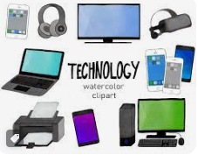  **TECHNOLOGY AFTER SPENDING $3,000.00**  S**UPPLIES and EQUIPMENT AFTER SPENDING $2,000.00** Gaming related items, cable tv, streaming services Clothing, food